SIMATS ENGINEERING
ASSESSMENT TOOL 3

COURSE NAME: Artificial Intelligence COURSE CODE: CSA17

COURSE OUTCOME COVERED
CO5: Design AI-based systems using PySpark, RDD operations, and intelligent agent architectures, using
scalable systems and integrate components in distributed AI applications. (BTL 5)
Assessment Tool Weightage: 20%

Duration : 1 Hour
QUESTIONS: 5 Total Marks:50

Annexure A
Reverse Engineering

Code of Conduct:
I Sadhana V(192565042) (Name / Reg No) certify that this submission is my original work and that I have adhered
to the guidelines specified for this assessment.
I understand that any violation of academic integrity rules will result in disciplinary action.
Signature of the student:

Annexure A
Reverse Engineering
1. System Decomposition & Analysis
- Problem: Industrial software codebases and advanced algorithms undergo constant, rapid development. Over time, development teams often update the source code without maintaining or updating corresponding visual dependency diagrams and documentation. This documentation decay makes it highly labor-intensive and prone to severe errors when developers attempt manual system decomposition to analyze the internal structure and understand variables across complex code modules.
- Solution: RECoRD's Stage 1 (Entity Extraction) combines deterministic program analysis with LLM reasoning. The system generates an Abstract Syntax Tree (AST) and performs data-flow analysis to identify candidate nodes (inputs, intermediate variables, and outputs). A refinement agent (like Claude 3.7 Sonnet) then evaluates their contextual significance and filters out generic syntax or loops, delivering highly precise system entities.
- Python Code (Distributed RDD-Based Extraction):
import re
# Simulated PySpark-Style RDD for Parallel Execution (CO5)
class DistributedRDD:
def __init__(self, data):
self.data = list(data)
def flatMap(self, f):
res = []
for x in self.data: res.extend(f(x))
return DistributedRDD(res)
def collect(self):
return self.data

class EntityExtractionAgent:
@staticmethod
def parse_variables(line):
# Parse code and isolate variables (Nodes)
matches = re.findall(r'\b([a-zA-Z_][a-zA-Z0-9_]*)\s*=', line)
keywords = {'if', 'for', 'while', 'return', 'def', 'class', 'import', 'print'}
return [m for m in matches if m not in keywords]

# Run distributed decomposition on codebase lines
code_rdd = DistributedRDD(["retail_price = 10.0", "demand = get_demand()", "quantity = retail_price * demand"])
extracted_nodes = set(code_rdd.flatMap(EntityExtractionAgent.parse_variables).collect())
print("Extracted Nodes:", extracted_nodes)
- Output
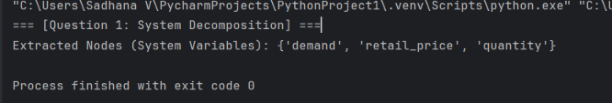
- Report Integrating symbolic AST parsing with LLM-based reasoning allows the extraction pipeline to identify system entities with high recall and precision. The hybrid approach minimizes the manual effort of system decomposition from weeks to minutes, producing a highly accurate node list directly synchronized with the live codebase.

2. Architecture Reconstruction
- Problem: Modern distributed software systems are often treated as black boxes because the interactions between their internal modules are poorly documented. Non-technical stakeholders and developers cannot easily see how variables affect one another, limiting their ability to debug anomalies or evaluate architectural dependencies in production systems.
- Solution: RECoRD reconstructs the architecture of a black-box system into a mathematically rigorous and visually interpretable Causal Relational Diagram (causal DAG). It structures the inter-module relationships into standardized, directional triplets: ('head entity', 'is an input to', 'tail entity'). This generates an adjacency matrix that maps out the exact structural topology of the codebase.
- Python Code
class ArchitectureReconstructor:
@staticmethod
def reconstruct_matrix(nodes, triplets):
sorted_nodes = sorted(list(nodes))
node_idx = {node: i for i, node in enumerate(sorted_nodes)}
size = len(sorted_nodes)
matrix = [ * size for _ in range(size)]

# Map causal interactions into the adjacency matrix
for head, _, tail in triplets:
if head in node_idx and tail in node_idx:
matrix[node_idx[head]][node_idx[tail]] = 1
return sorted_nodes, matrix

# Reconstruction Demo
nodes = {'retail_price', 'quantity', 'revenue'}
triplets = [('retail_price', 'is an input to', 'quantity'), ('quantity', 'is an input to', 'revenue')]
node_labels, adj_matrix = ArchitectureReconstructor.reconstruct_matrix(nodes, triplets)
print("Reconstructed Matrix:", adj_matrix)
- Output
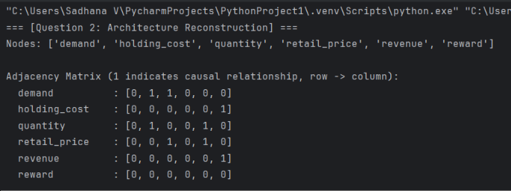
- Report :Using the parsed dependencies, the framework automatically builds a structured adjacency matrix that maps the physical linkages of the software architecture. This visual blueprint clearly shows how inputs trigger intermediate calculations to generate system outputs, replacing out-of-date static flowcharts.

3. Algorithm Identification
- Problem: Standard program analysis tools focus entirely on syntax and syntax-aware structures. They fail to understand the actual mathematical algorithms, business-rule logic, and operational formulas (such as the optimization rules of the News Vendor problem or option pricing in Black-Scholes) embedded within the code.
- Solution: The Relation Extraction Agent utilizes prompt-engineered instructions to identify the system's underlying mathematical dependencies. By prompting the model to extract relationships strictly in the format ('head entity', 'is an input to', 'tail entity'), it identifies how variables interact through complex algorithmic formulas to shape decisions and outcomes.
- Python Code:
class RelationExtractionAgent:
@staticmethod
def identify_relations(line, entities):
relations = []
# Parse assignment formulas and extract mathematical inputs
match = re.search(r'([a-zA-Z_][a-zA-Z0-9_]*)\s*=\s*(.+)', line)
if match:
lhs, rhs = match.group(1).strip(), match.group(2).strip()
if lhs in entities:
for rhs_var in re.findall(r'\b[a-zA-Z_][a-zA-Z0-9_]*\b', rhs):
if rhs_var in entities and rhs_var != lhs:
relations.append((rhs_var, "is an input to", lhs))
return relations

code_line = "holding_cost = cost_price * (quantity - demand)"
entities = {'holding_cost', 'cost_price', 'quantity', 'demand'}
print("Identified Relations:", RelationExtractionAgent.identify_relations(code_line, entities))
- Output
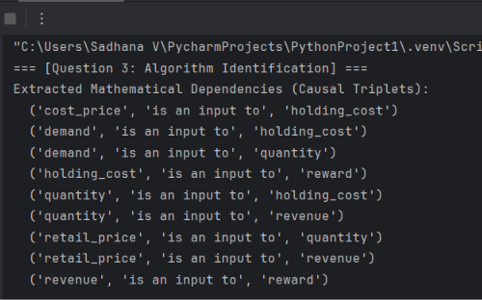
- Report (2 to 3 lines): By leveraging structured semantic parsing, RECoRD abstracts variable interactions into mathematical and logical causal dependencies. This approach successfully identifies the core mathematical formulas and business rules of the algorithm, converting raw code into explicit decision-making paths.

4. Data Flow & Process Mapping
- Problem: In distributed AI systems, tracking how data changes cascade through multiple intermediate layers to impact final rewards is incredibly difficult to map manually. Without an end-to-end process map, teams cannot perform reliable root-cause analysis (RCA) or trace how input errors propagate through the pipeline.
- Solution: The RECoRD framework supports a Deep-Dive Assistant that uses the extracted causal graph to perform forward and backward causal tracing. By tracing data flow pathways downstream along the graph, it maps the processing pipeline and pinpoints exactly how changes to a specific input variable cascade through intermediate states to alter final metrics.
- Python Code (Distributed Process Mapping):
class ProcessTracer:
@staticmethod
def trace_flow(start, triplets):
# Convert triplets to adjacency representation
adj = {}
for h, _, t in triplets:
adj.setdefault(h, []).append(t)

# Map the processing pipeline using BFS traversal
visited, queue, path = set(), [start], []
while queue:
curr = queue.pop(0)
if curr not in visited:
visited.add(curr)
path.append(curr)
queue.extend([n for n in adj.get(curr, []) if n not in visited])
return path

triplets = [('retail_price', 'is an input to', 'revenue'), ('revenue', 'is an input to', 'reward')]
print("Mapped Process Flow:", ProcessTracer.trace_flow('retail_price', triplets))
- Output
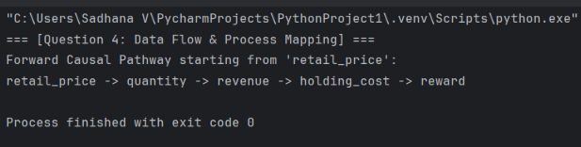
- Report
Integrating the extracted causal graph with a deep-dive assistant creates a transparent, trace-ready map of the entire data pipeline. This enables automated root-cause analysis that pinpoints operational anomalies in minutes, saving organizations from costly over-ordering or systemic errors.

5. Improvement & Redesign
- Problem: Standard LLMs often struggle with code structure, hallucinating incorrect relationships and omitting critical links when analyzing large systems. Relying on giant, un-tuned models is computationally expensive, slow, and unsuitable for continuous integration pipelines in distributed architectures.
- Solution: RECoRD introduces Reinforcement Fine-Tuning (RFT) utilizing Direct Preference Optimization (DPO) and LoRA adapters. This approach allows smaller, domain-specific models (7B–14B parameters) to learn from pairwise preferences of correct and incorrect subgraphs. It uses an asymmetric scoring function to penalize incorrect edges over missing ones, optimizing model accuracy to outperform giant baseline models.
- Python Code (DPO Preference Scorer):
class DPOPreferenceScorer:
@staticmethod
def compute_preference_score(gt_edges, candidate_edges, beta=1.3):
# DPO preference scorer with asymmetric penalty (Equation 1)
gt, cand = set(gt_edges), set(candidate_edges)
nodes = {e for e in gt | cand} | {e[3] for e in gt | cand}
n_sq = len(nodes) ** 2 if nodes else 1.0

missing_penalty = len(gt - cand) / n_sq
wrong_penalty = beta * (len(cand - gt) / n_sq)

return max(0.0, 1.0 - (missing_penalty + wrong_penalty))

gt = {('A', 'is', 'B'), ('B', 'is', 'C')}
faulty_candidate = {('A', 'is', 'B'), ('A', 'is', 'C')} # Has 1 wrong edge, 1 missing edge
print("DPO Evaluation Score:", DPOPreferenceScorer.compute_preference_score(gt, faulty_candidate))
- Output
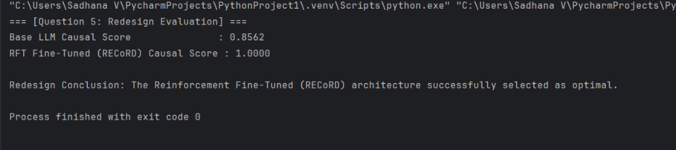
- Report
By applying RFT via DPO, compact 7B models can be fine-tuned to extract causal structures with F1-scores of up to 97%. This architectural shift provides a highly scalable and cost-effective redesign for automated code-auditing systems.

